ASSIGNMENT 3

|  |  |
| --- | --- |
| Name | Sonaal Kalra |
| Submitted To | Mr. Anand Rao |
| Company | Hanu Software |
| Date | 27/10/2018 |
| Version | 1.0 |



1.)Create a VM in Azure and on that VM build a Flask app with the MongoDB API Using cosmosDB.

Sol.

Step 1: First, create a virtual machine in Azure Portal



The fig. below shows the successful deployment of the virtual machine.



Step 2: Then created my Azure Cosmos Db Account With a name = "skaydb".

-> In this, choose the MongoDB API as required per the question.





This shows successful deployment of Cosmos DB.

Step 3: Then Open the VM after connecting by downloading the RDP file and and then installing the Git- bash.



Step 4: Then clone the app project in my virtual machine using git by typing some commands:

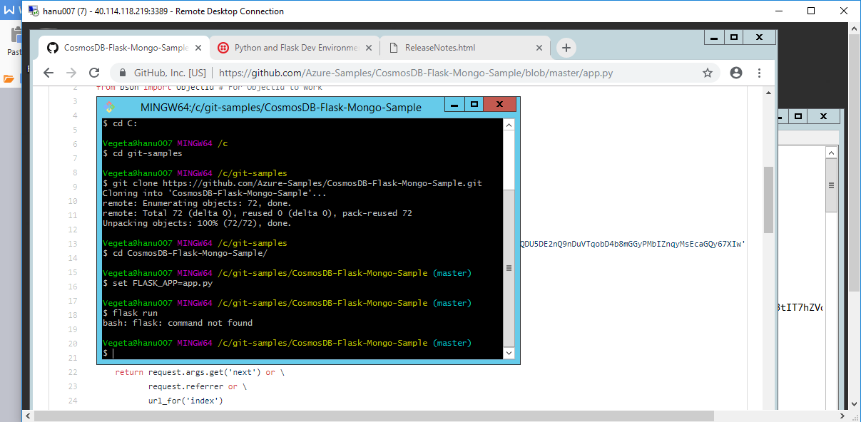

Step 5 : Then make changes in the app.py file by editing :

1. MongoDB client
2. Localhost
3. Password



Step 6: Then Install **python 3.7** Setup and get the **pip.py** from the internet and run it on Command prompt.

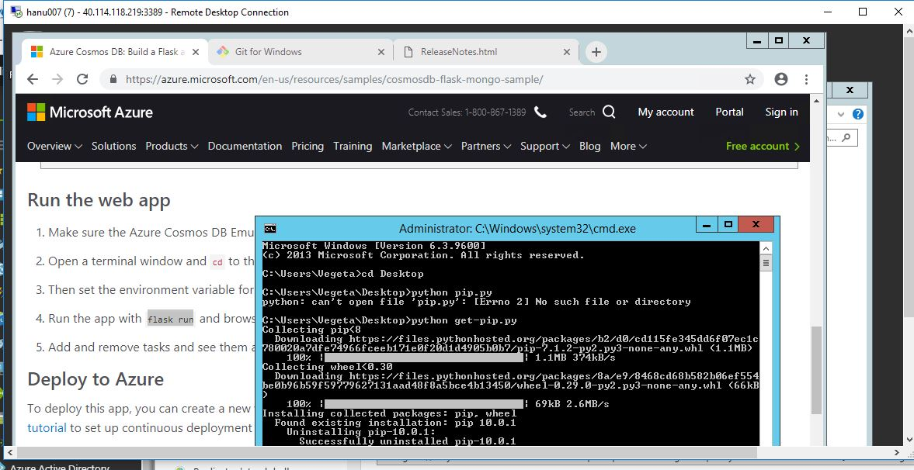

Step 7 : Then set the path of flask app environment variables and finally run it.

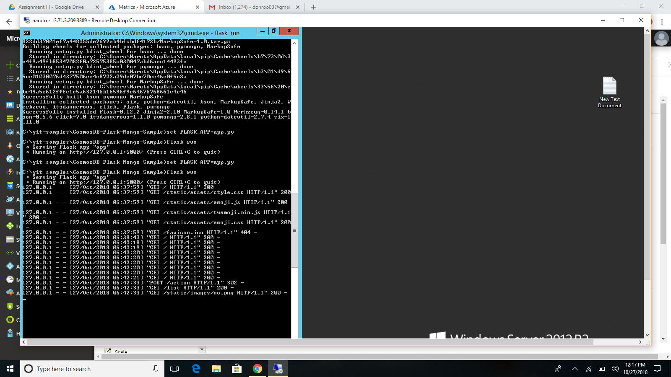

The final output that is shown in the browser is:

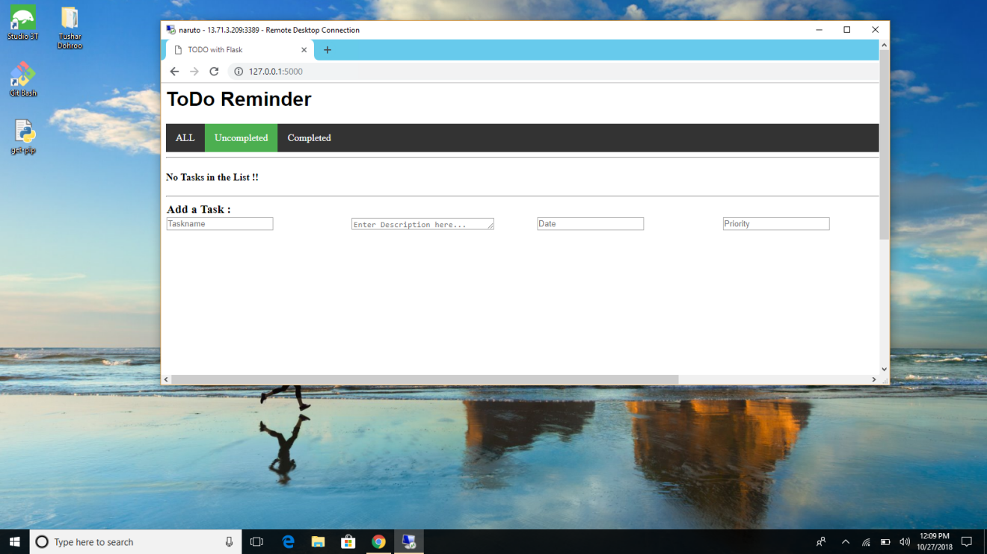

2.)Domain: Ansible (25 Marks)

1) Create a playbook / yml file to deploy a Sql database with the following configuration.

SQLDB Name : hanuemployeedatabase

Sql db server name : hanusql_server01

2) Create a playbook / yml file to deploy a VM ( linux ) in azure . use SSH keys to login to

the VM . Deploy a webapp in the linux instance that shows “Welcome to Hanu Software” on index.html

Sol.

1.)

Follow the following steps:

Step 1:

To create the database using ansible go to portal and click on cloud shell as follows:



Step 2: Now we need to create a yml file where we can write code, So type vi filename.yml :

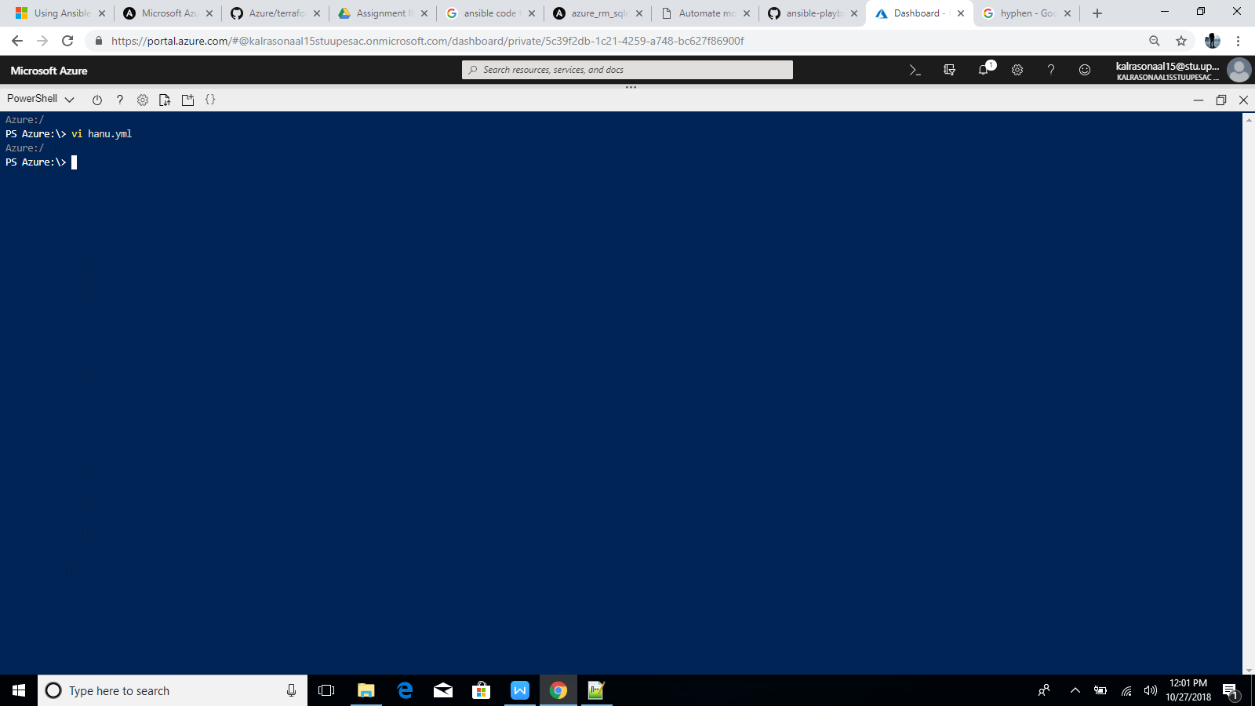

Step 3: Now the editor will pop up and insert using I and to commit use escape key and the write :wq to commit the changes.

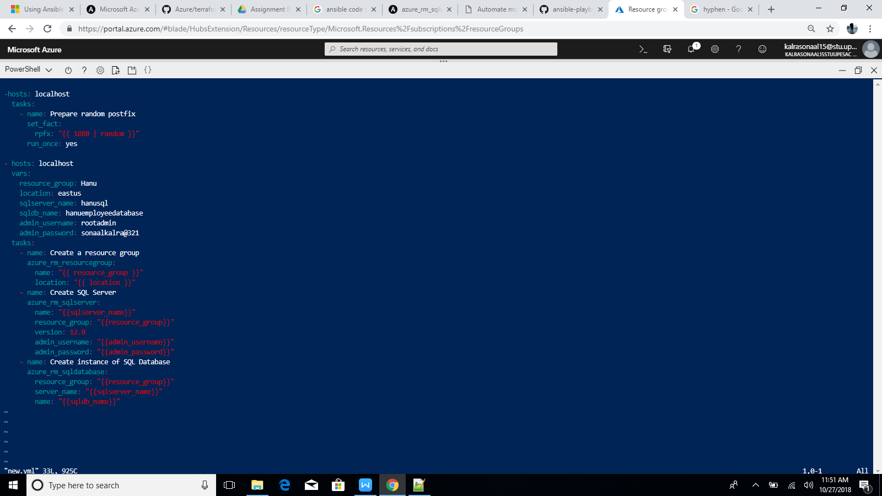

Step 4: Now run the following command (ansible - playbook filename.yml):

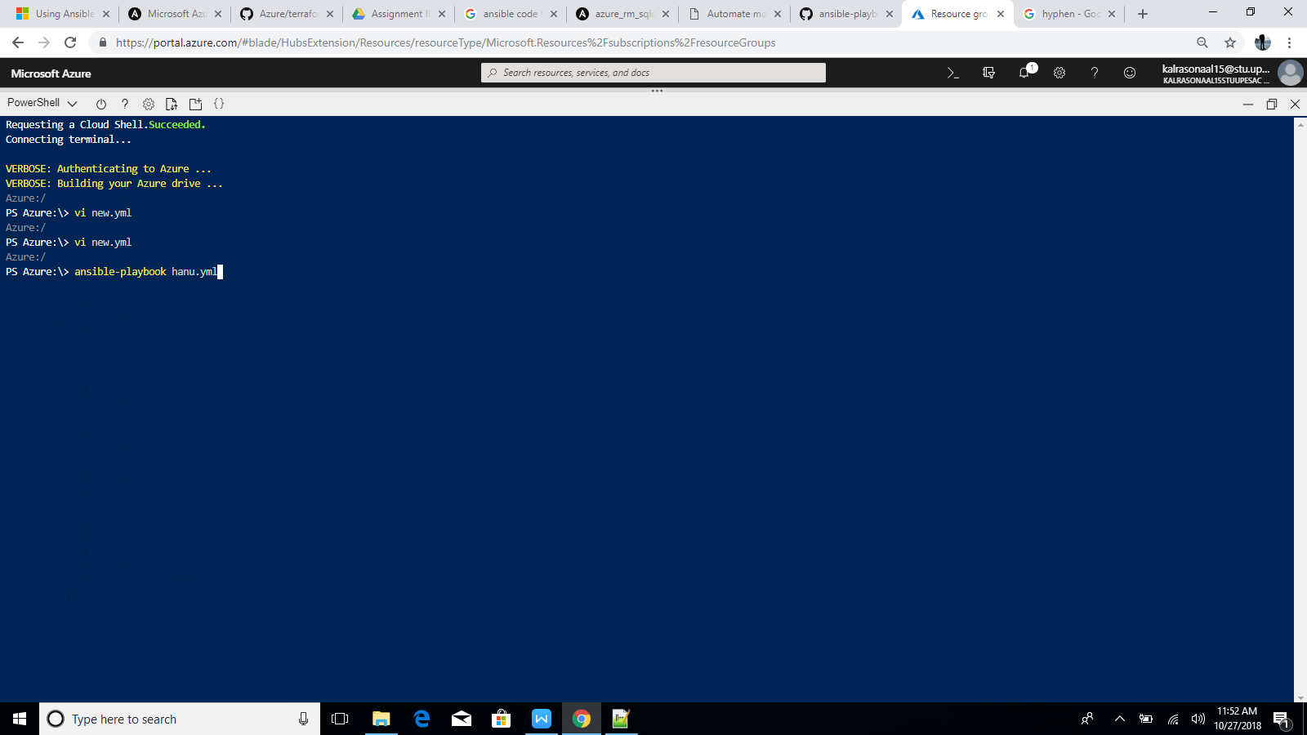

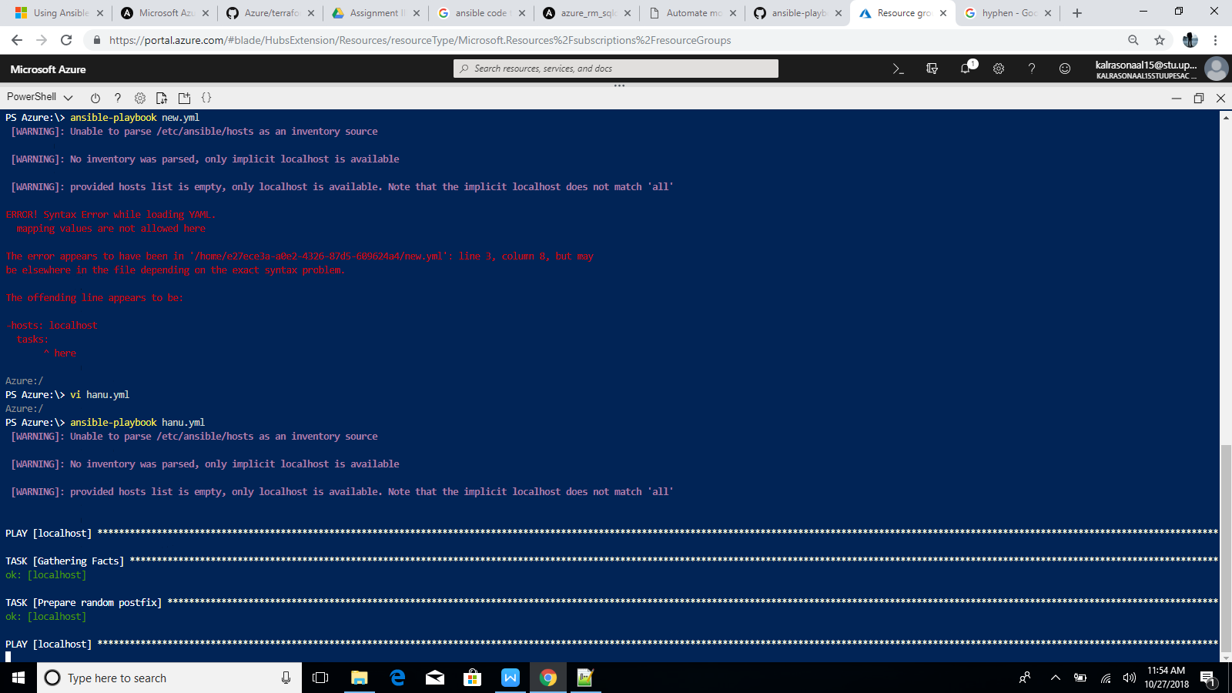

Wait for the above process to complete and it looks like :

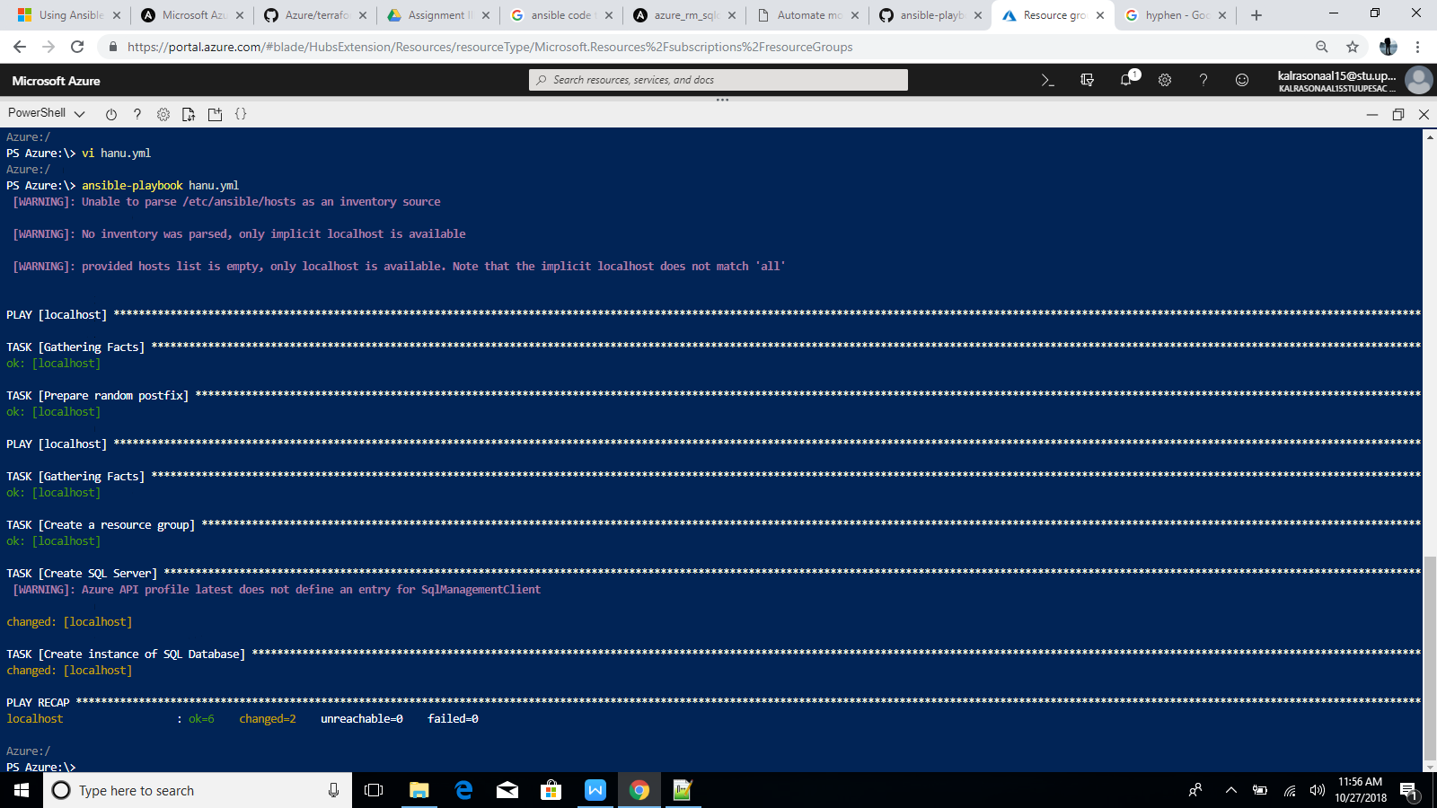

After successfully deployed check it in the portal:

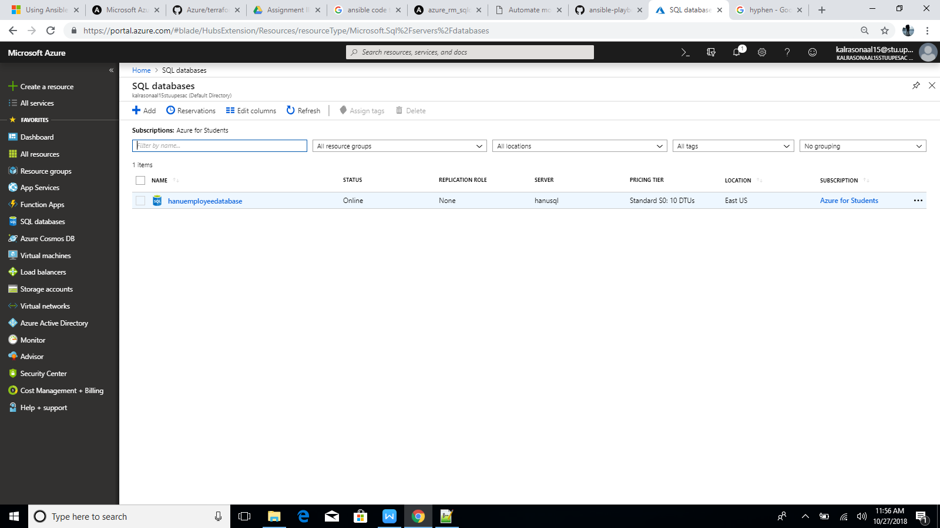

2:)

Here lets follow above steps and edit the code by generating the ssh keys:

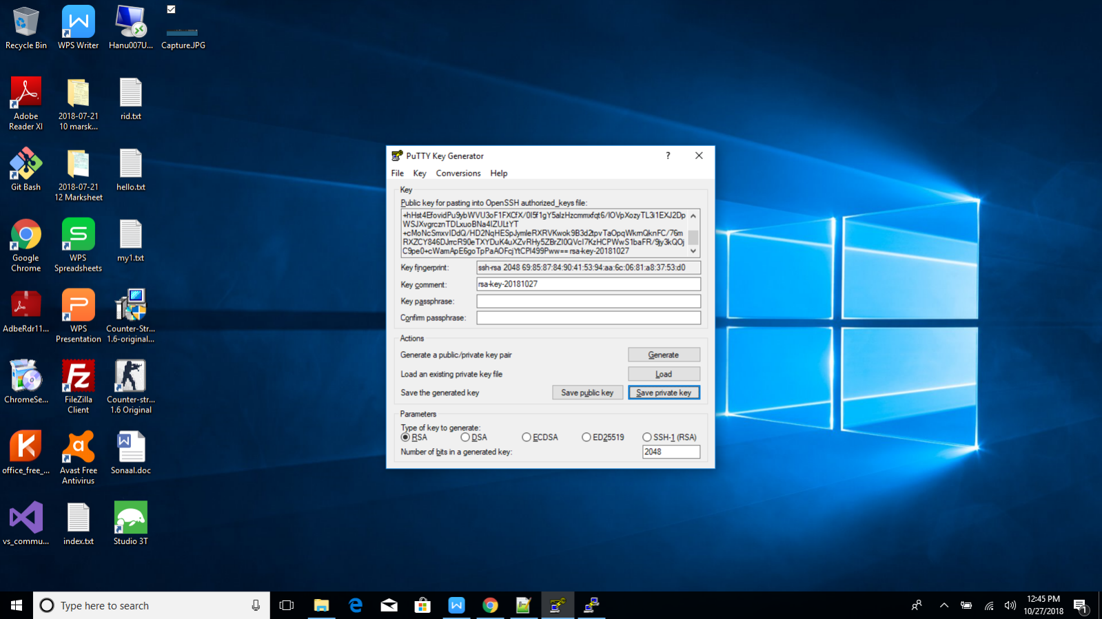

Now the code will look like:

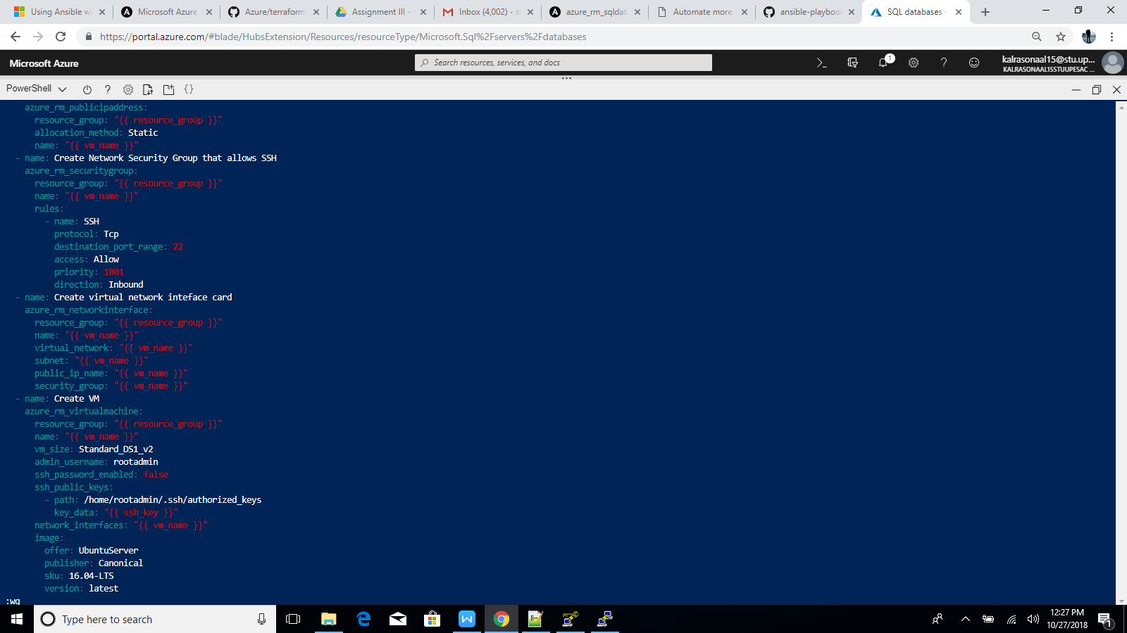

Now run the file:

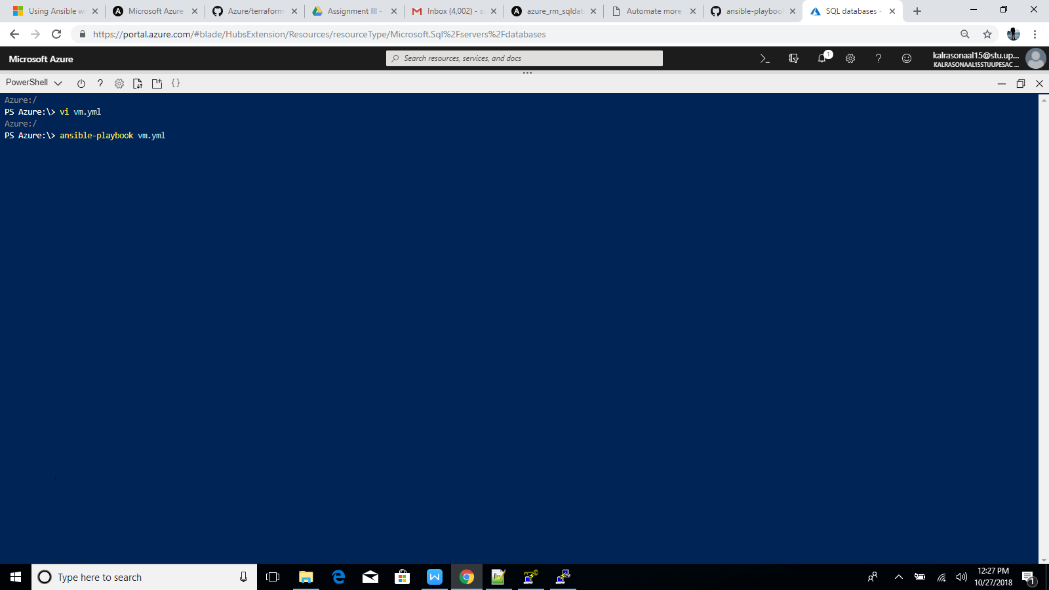

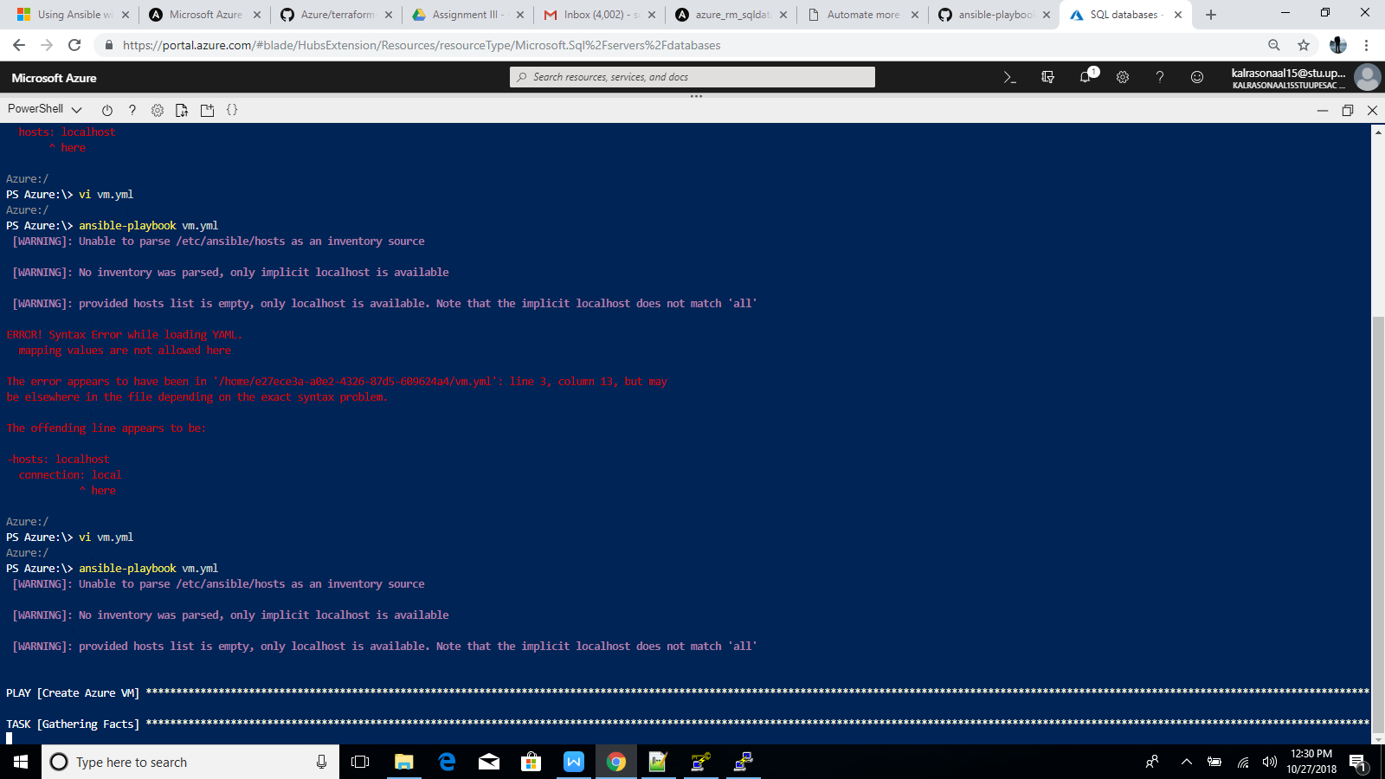

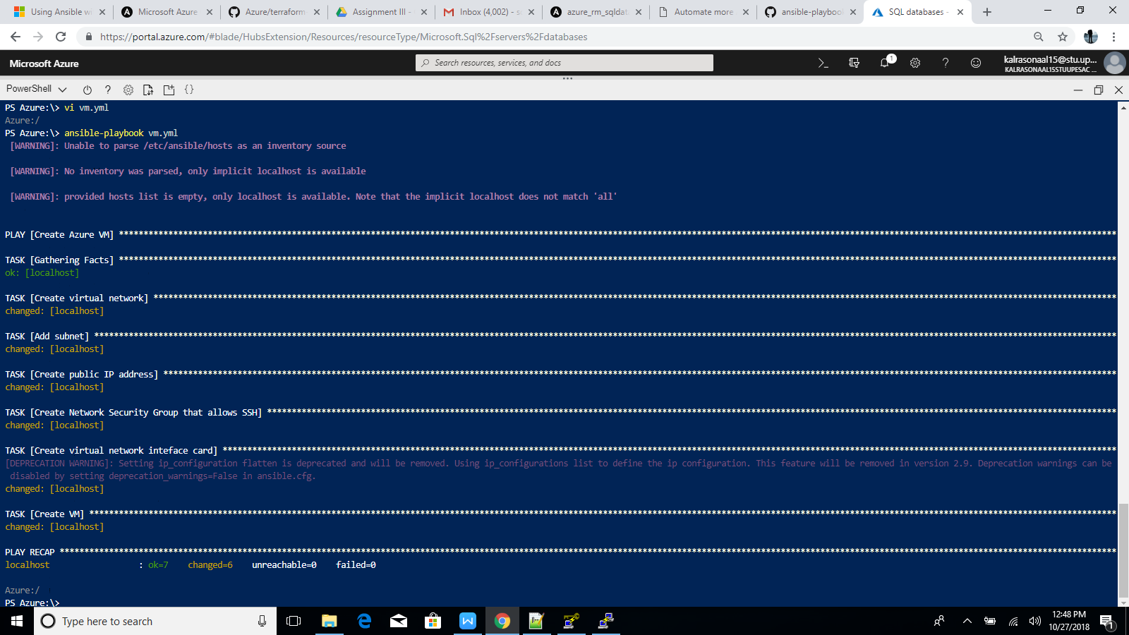

Now follow the steps to connect the Vm using putty:

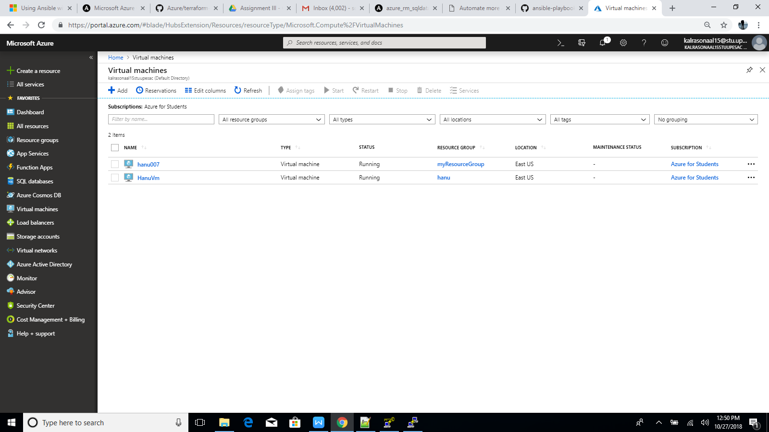

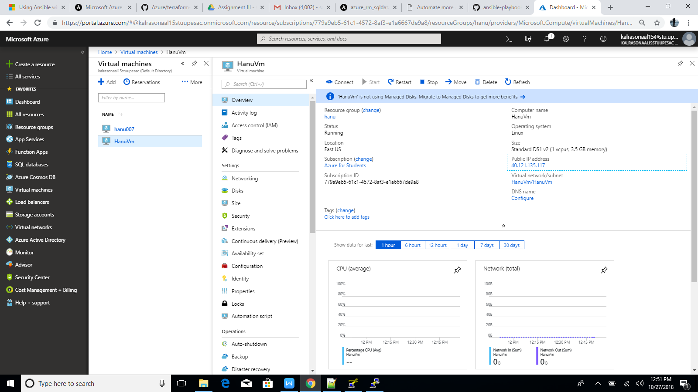

Now copy the public ip and paste it in putty:

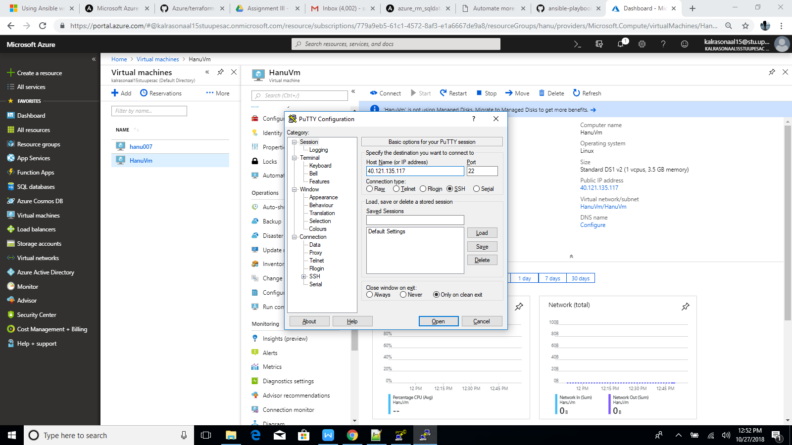

Now login as username

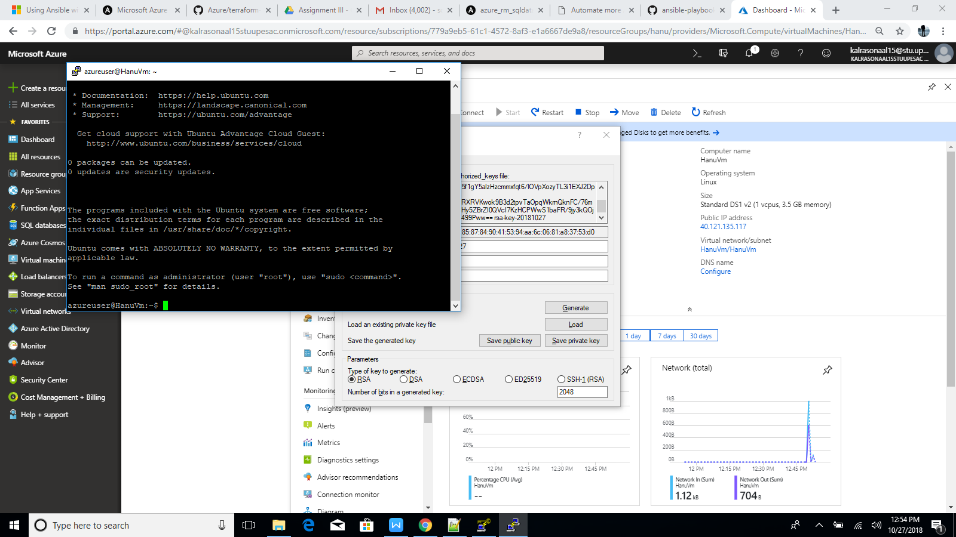

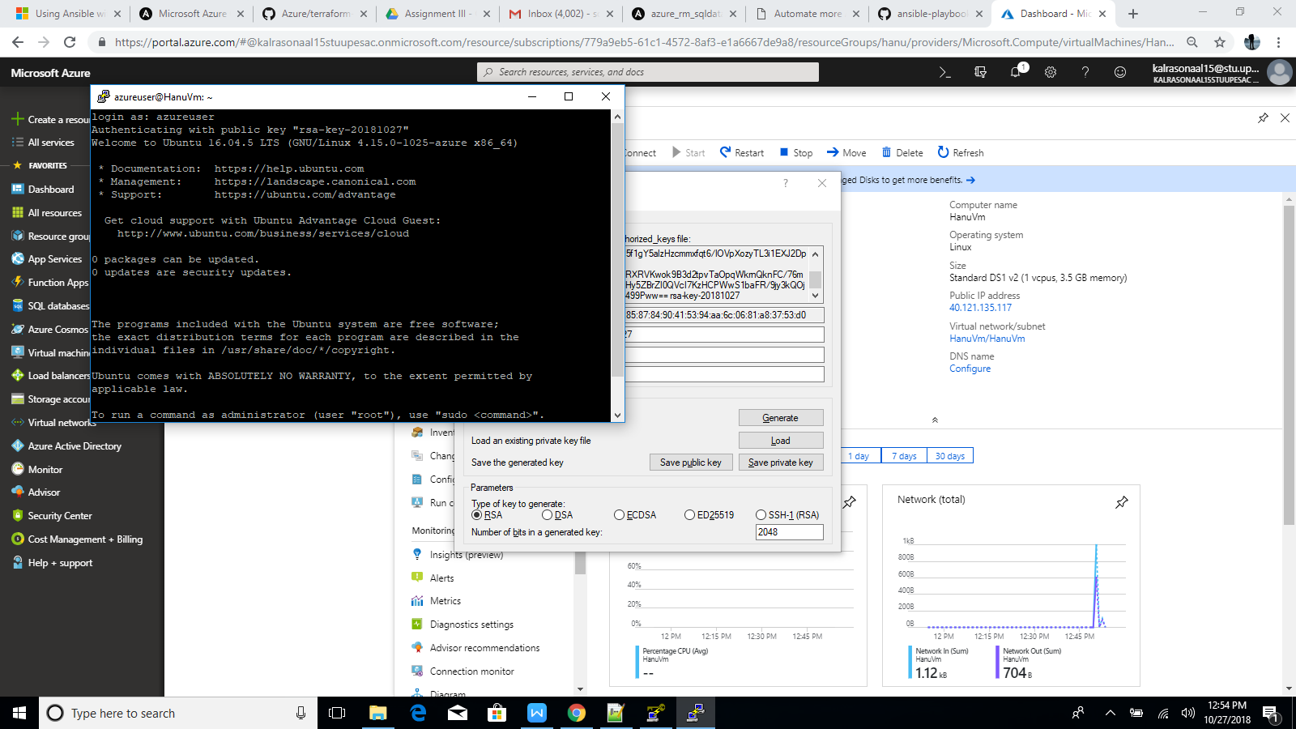

Now run the commands to get into the directory

Var/www/http/index.html

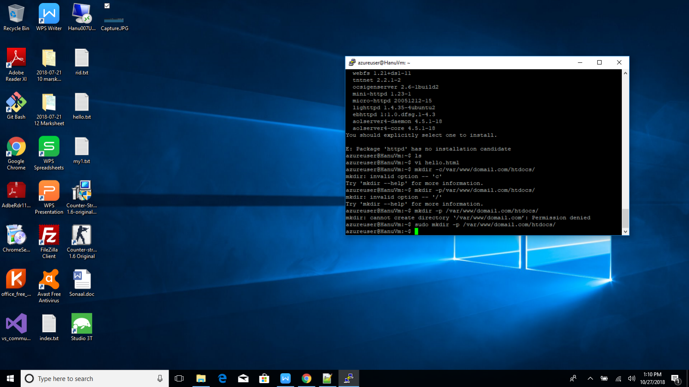

Now

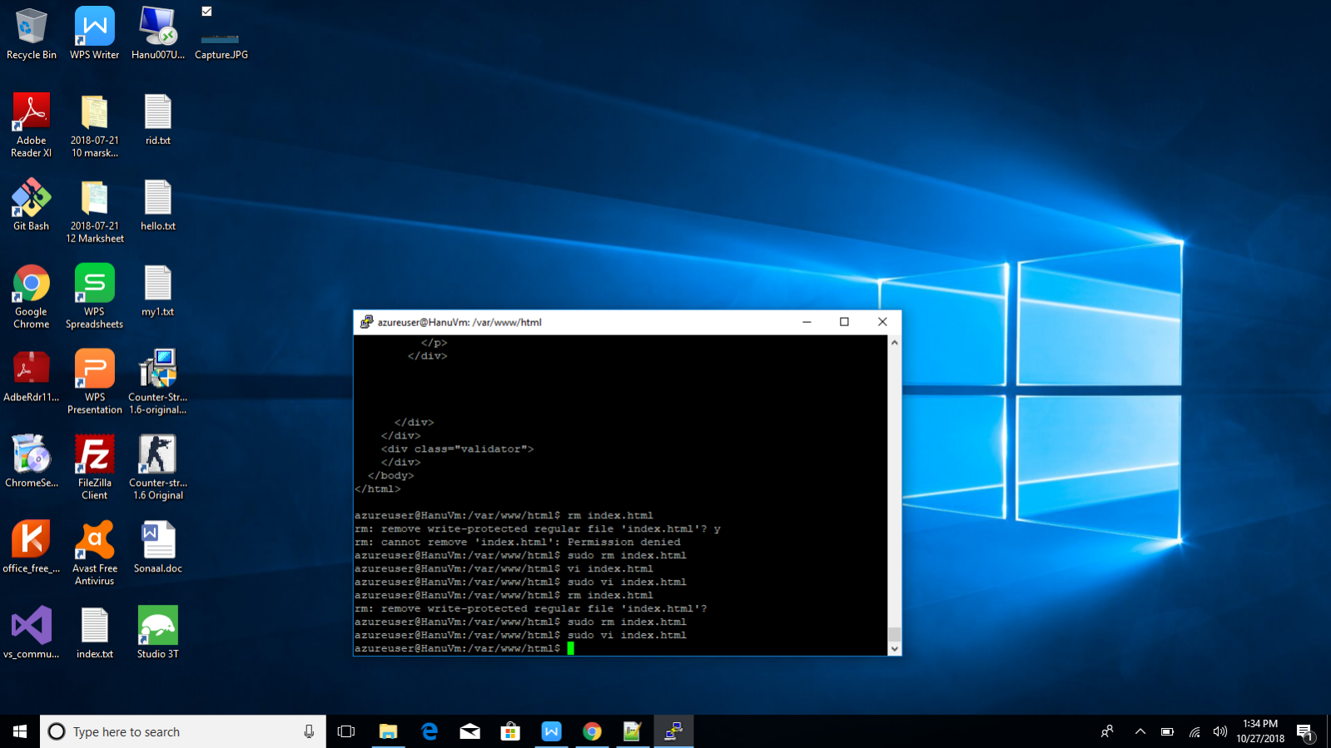

Now Edit the file index.html and write Welcome to Hanu amd copy the ip of VM and paste it in browser and enter:

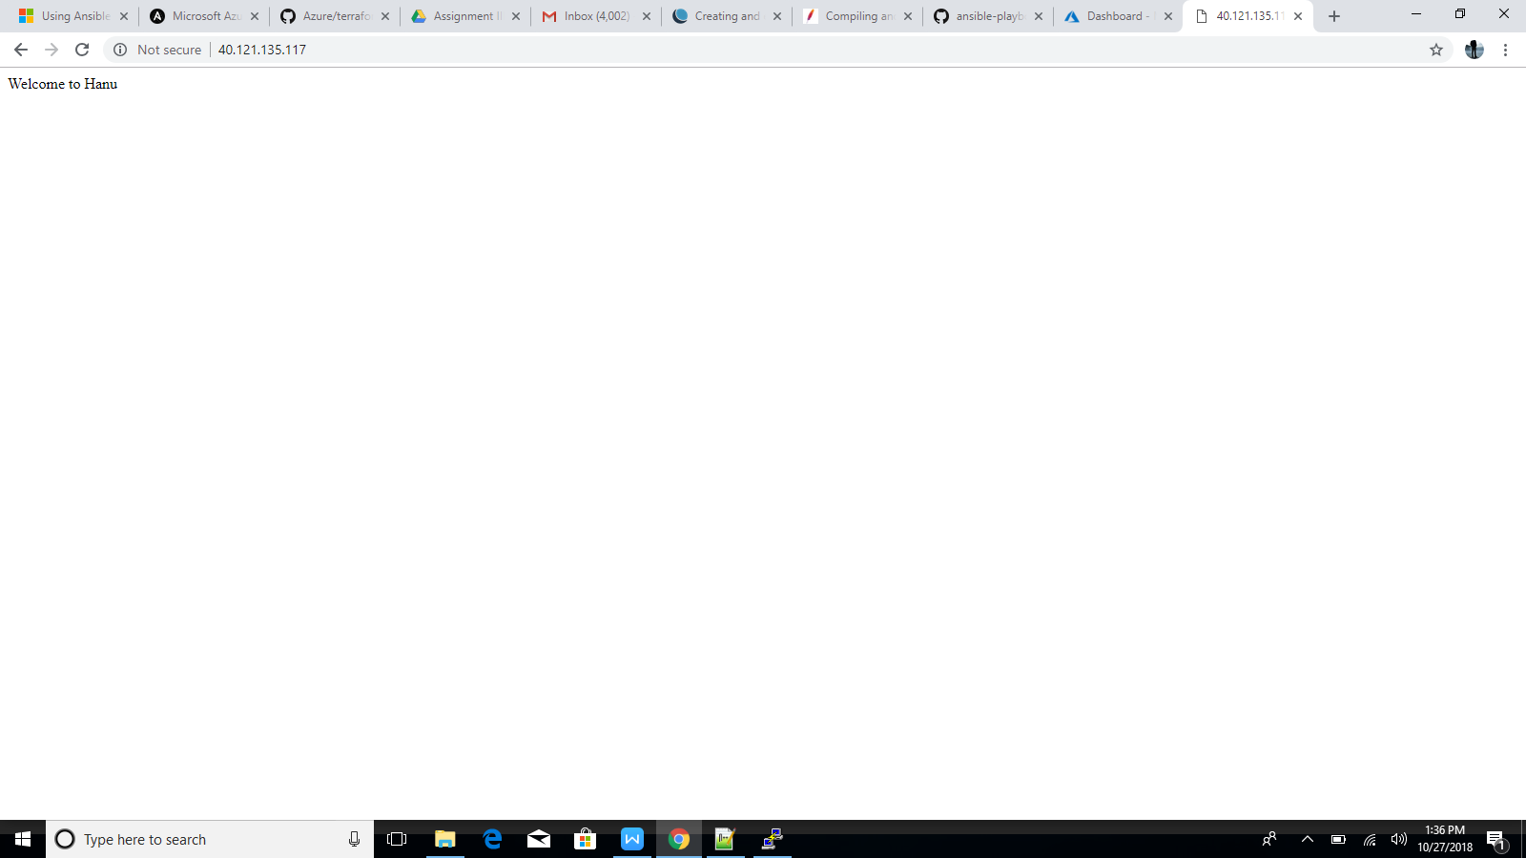

3.)Create a .tf file to deploy a VM in azure with the following configuration.

1) VM name : Hanuweb01

2) Resource group : Hanu_resources

3) Tags :

a. Owner = owner@hanu.com

b. Appowner : appteam@hanu.com

c. Severity : high

d. Status : production.

4) SSH based login : Enabled

5) Boot diagnostics : Not required.

6) Location : closer to Germany

Sol.

Follow the steps and run the commands in Azure Cloud Shell:





Use Terraform init command for running the file:





Type “yes” in the Enter the Value:





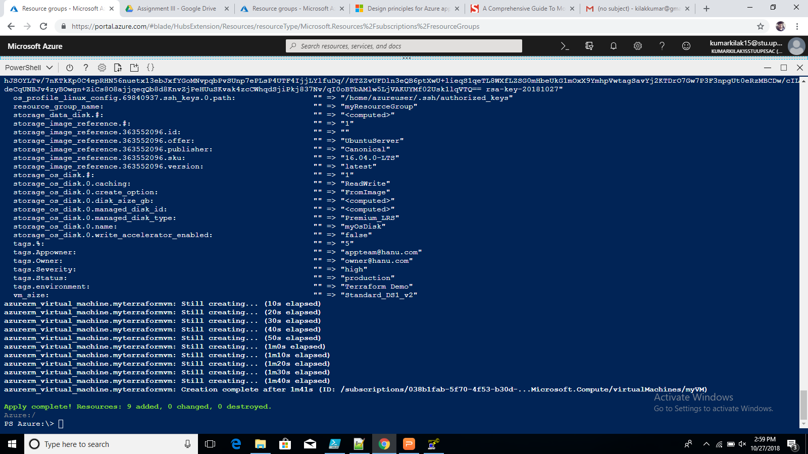

Hence check in portal if the vm being created or not:

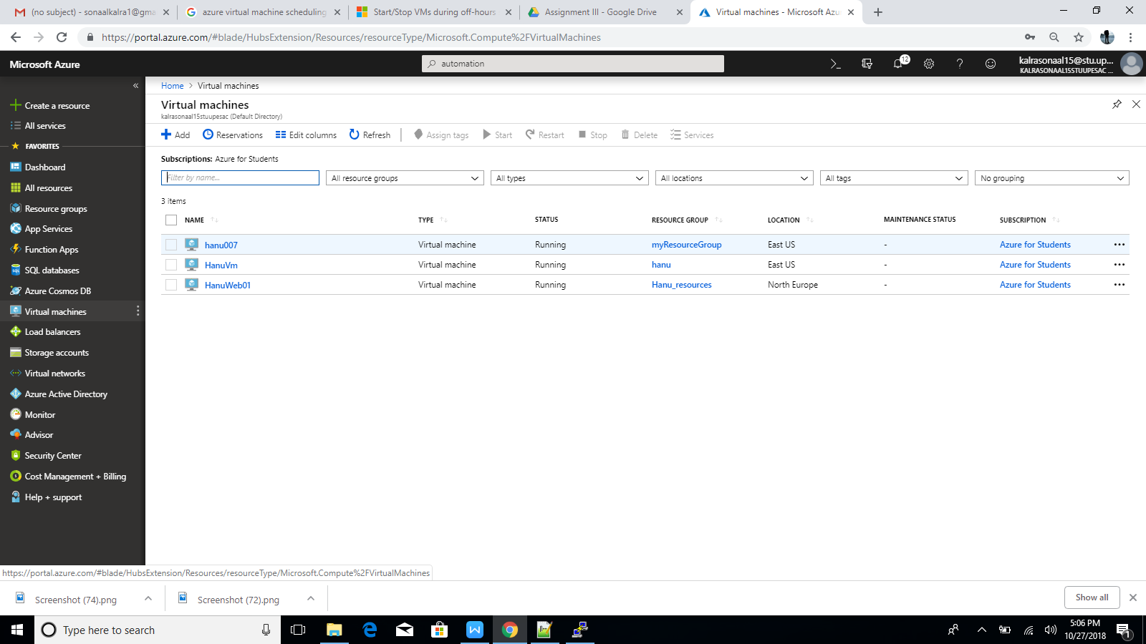

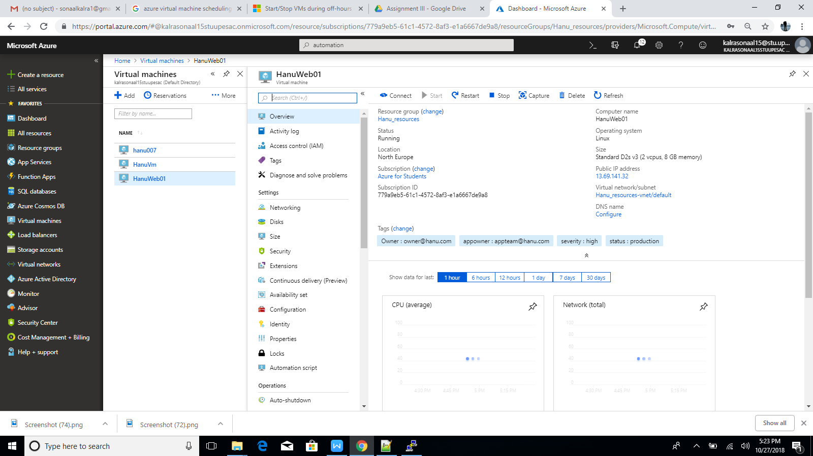

4.)Create an automation account to restart a VM and schedule a restart at a scheduled interval. The

restart must be a recurring monthly event.

Sol.

Follow the bellow steps to create an automation account:

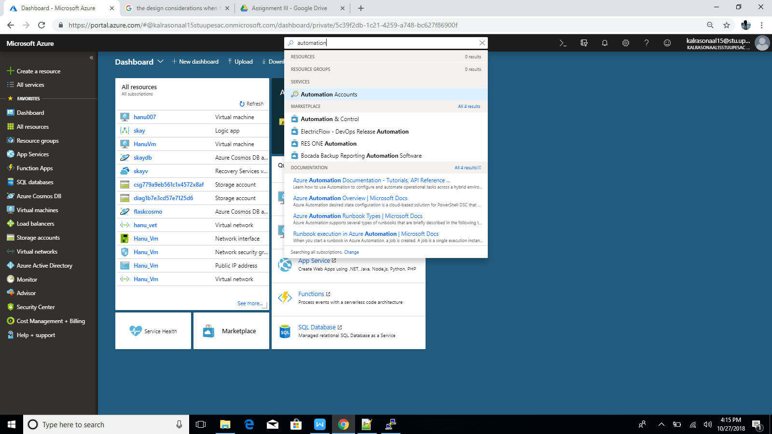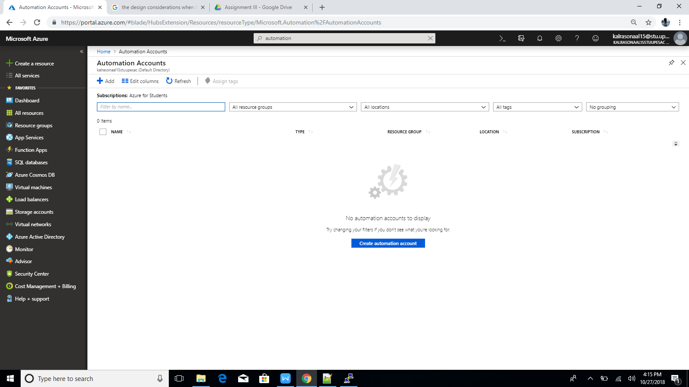

Now lets create an automation account first:

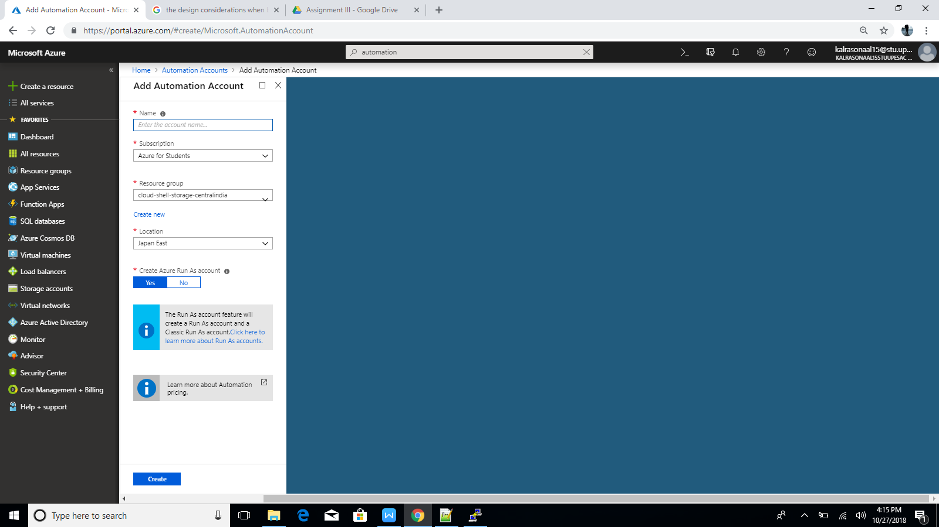

Fill the details:

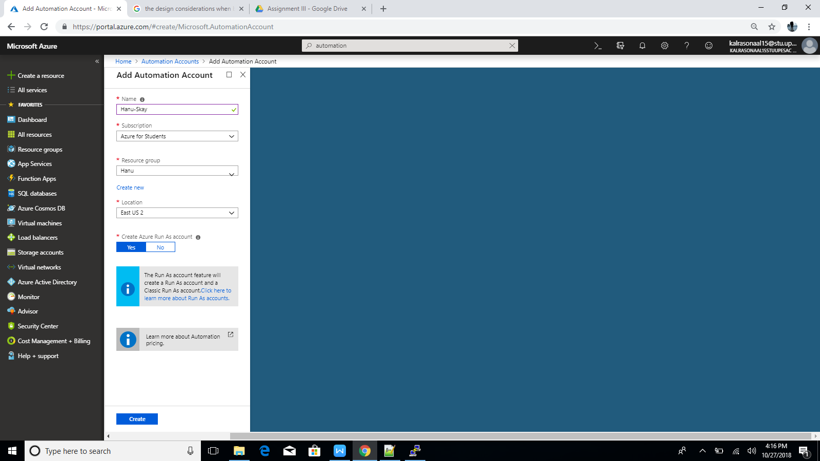

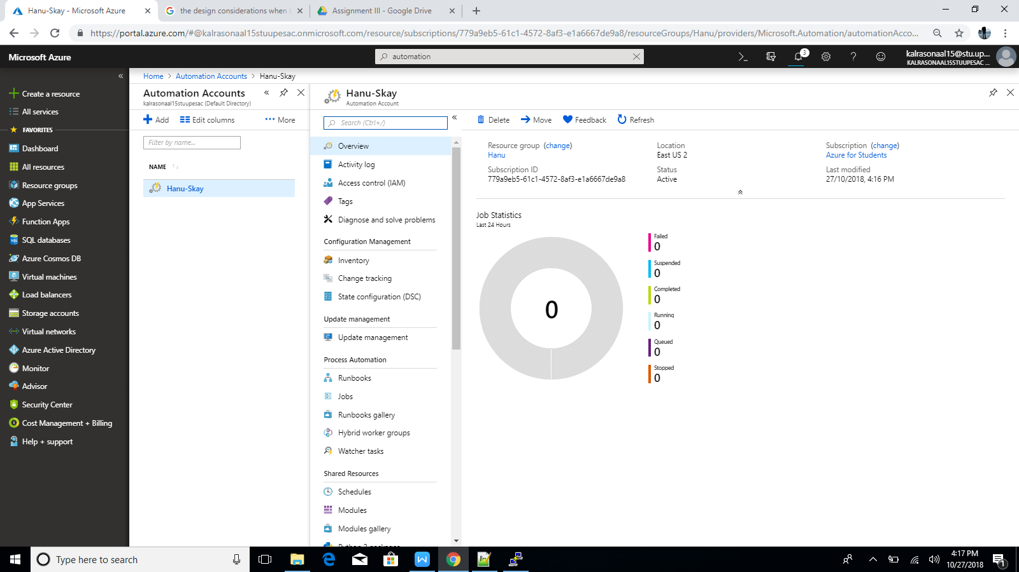

Go to Runbook gallery:

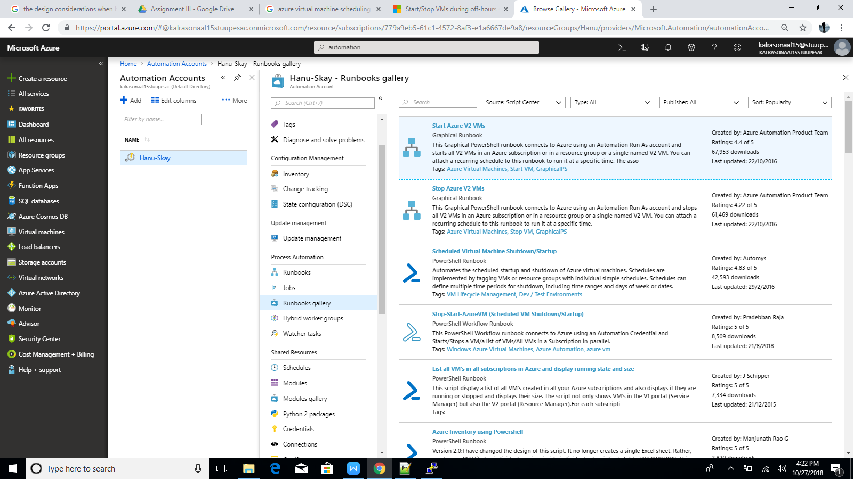

Choose the above option:

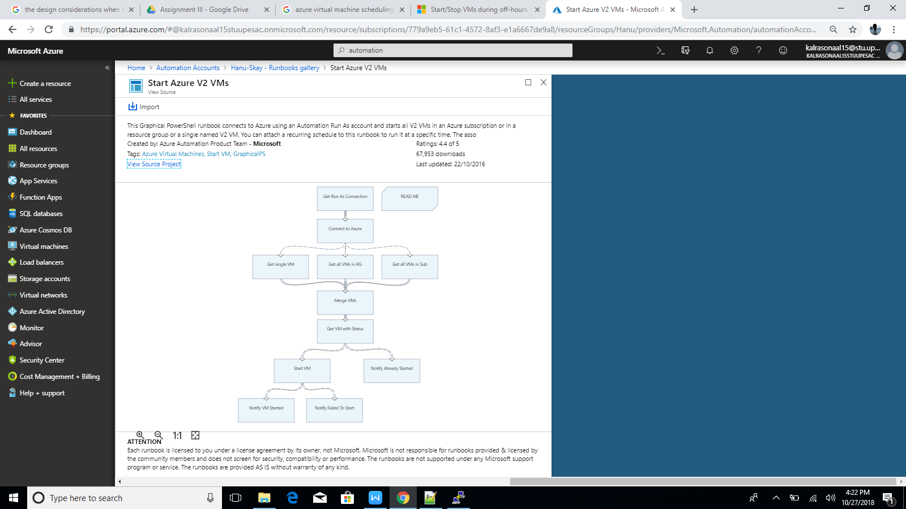

Click on Import:

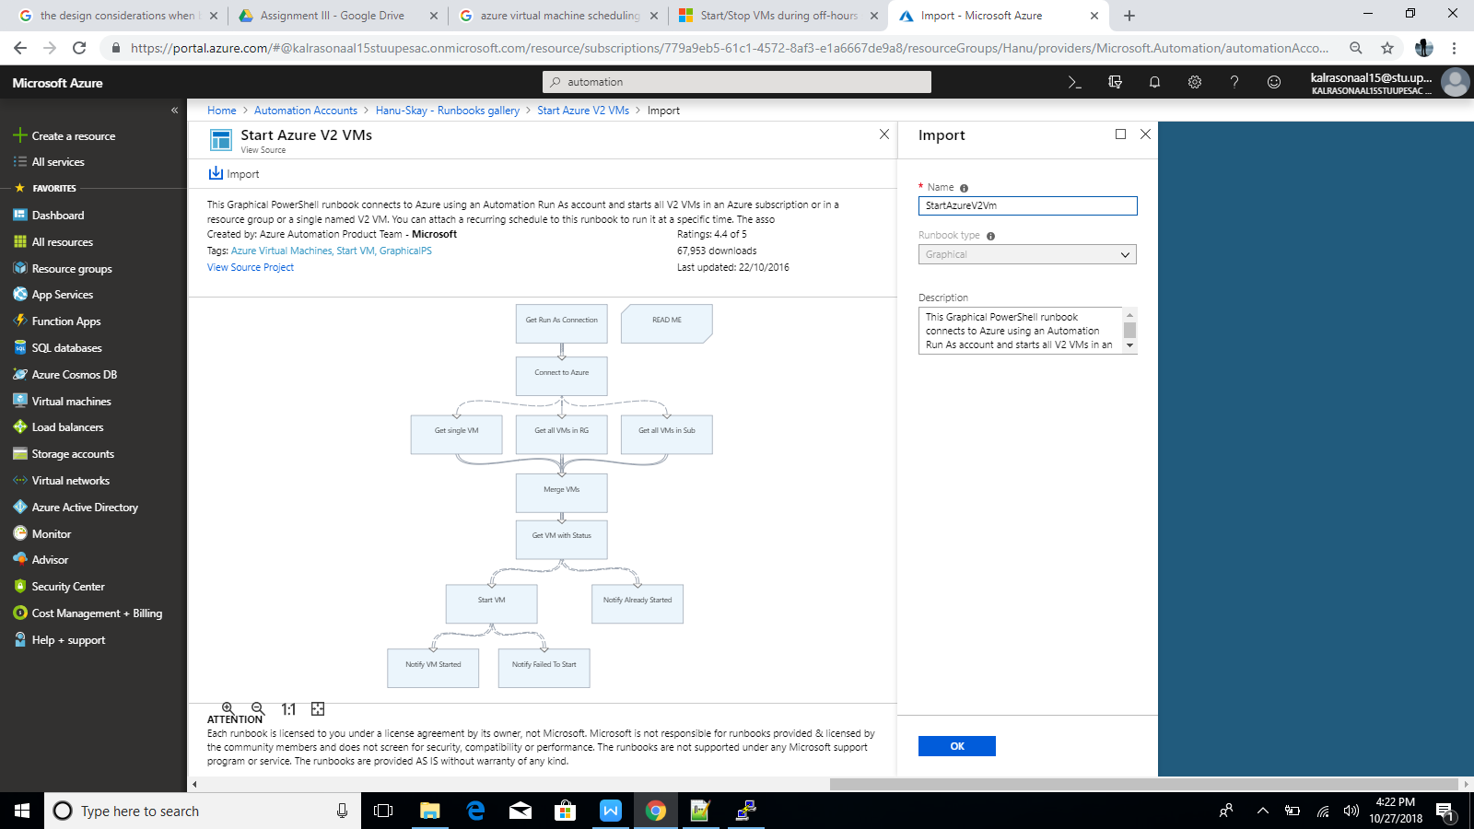

Now go to Runbook:

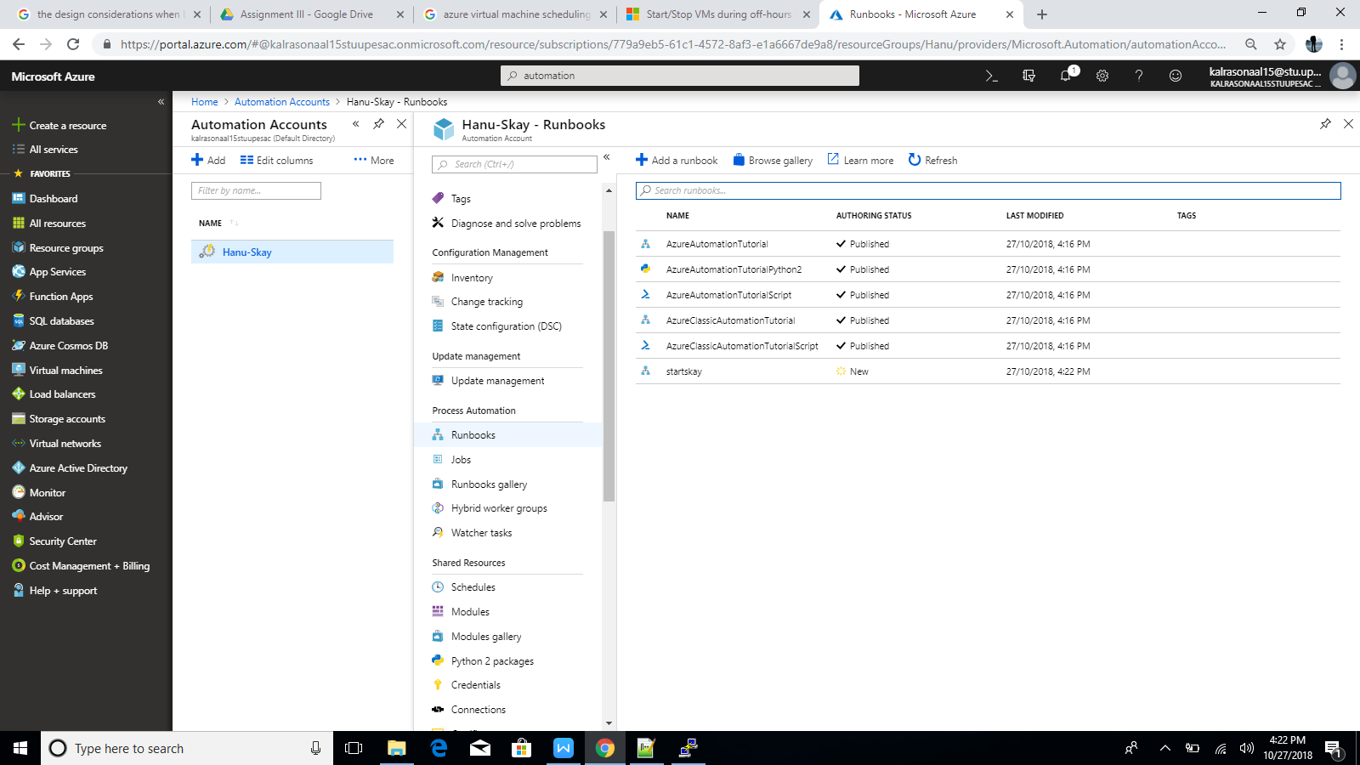

Now Click on publish :

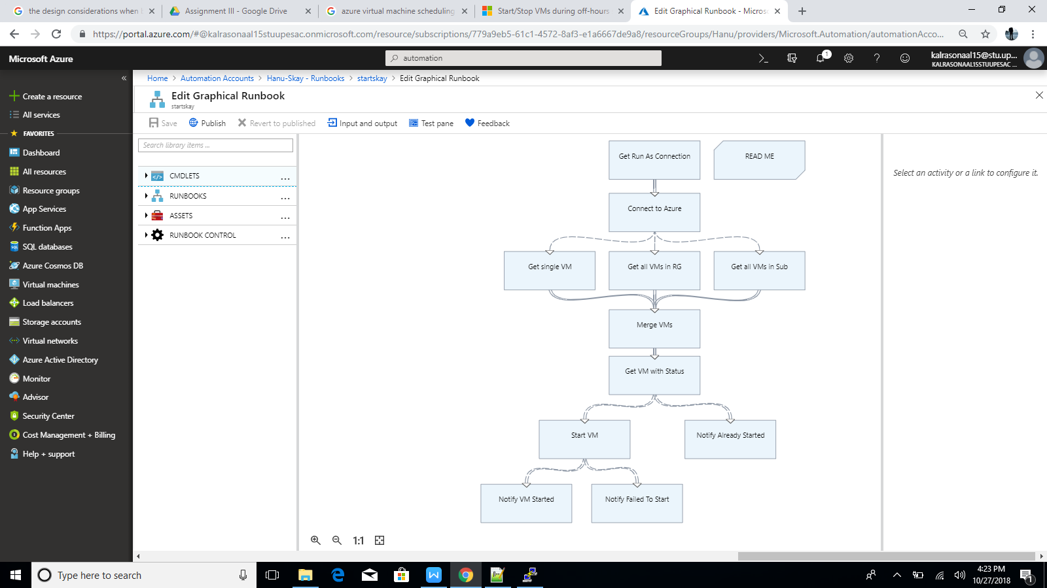

Now start the Runbook:

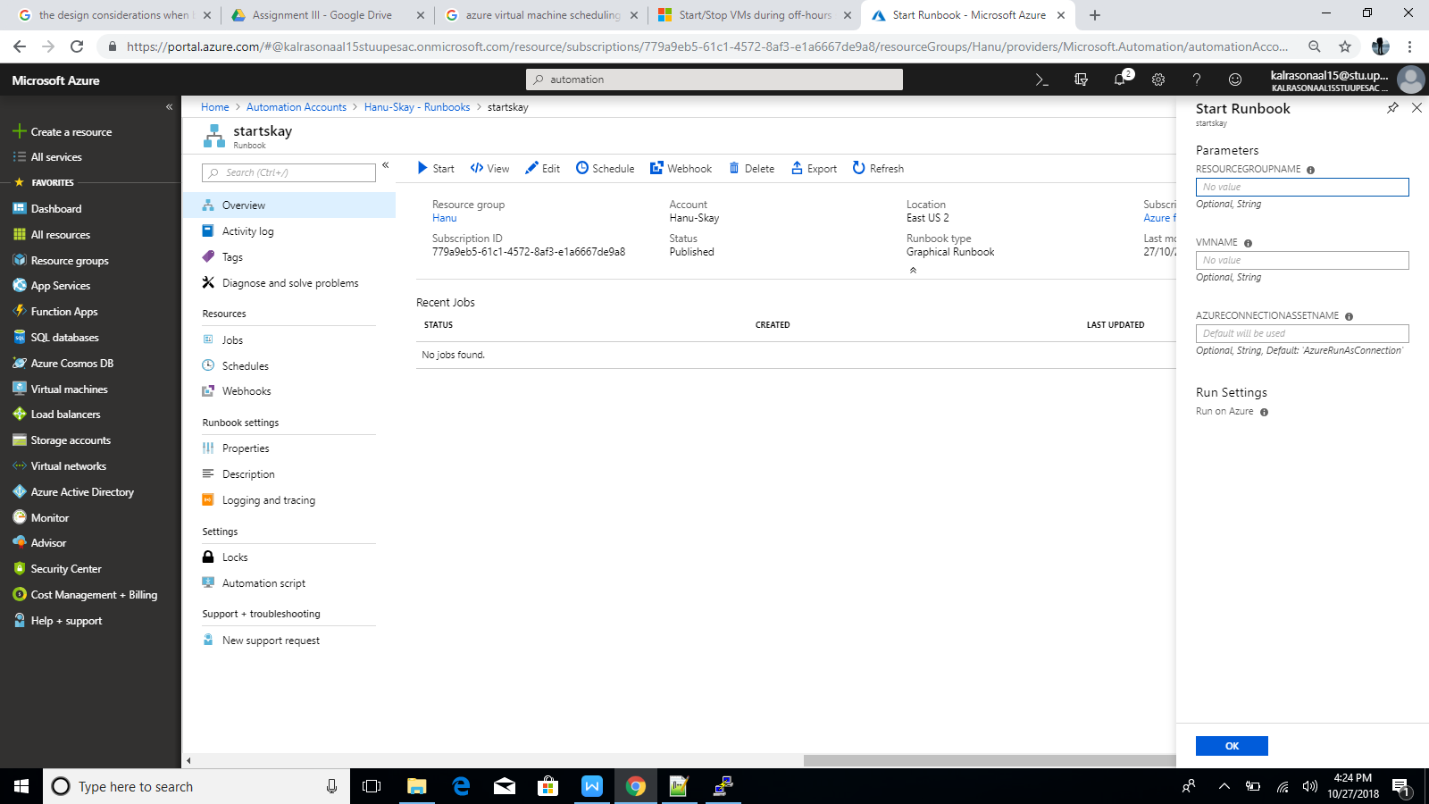

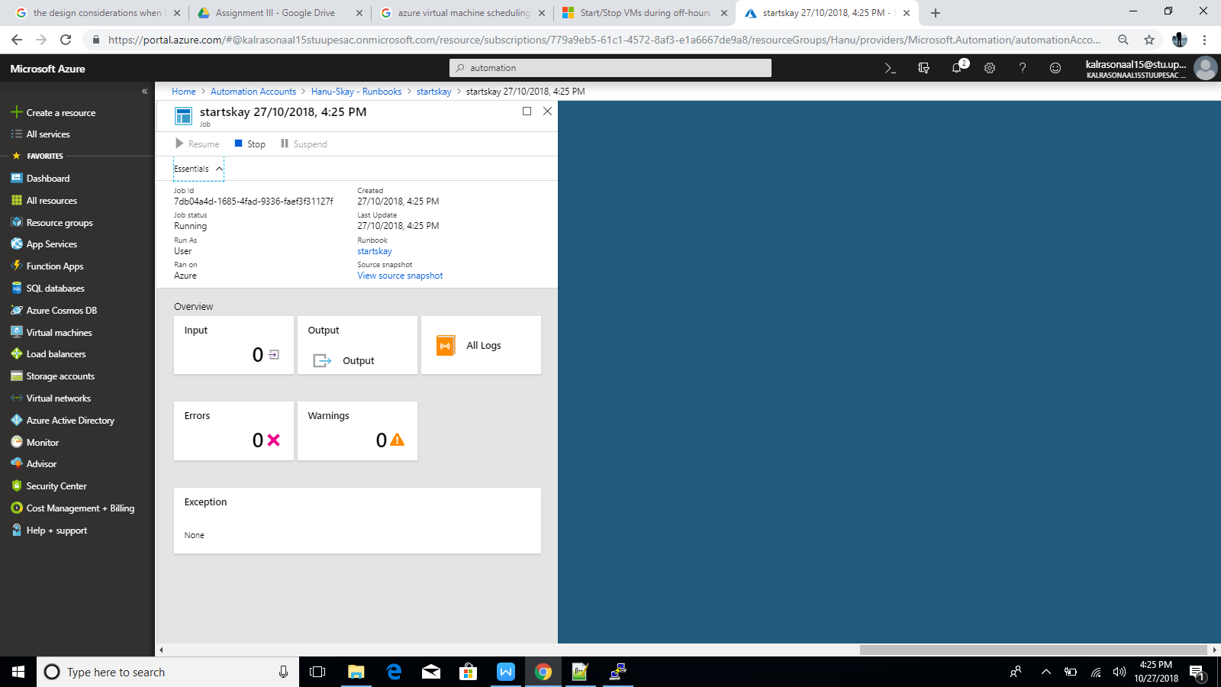

Here it is the Vm has been started but it shows that VM is already running because it was already running :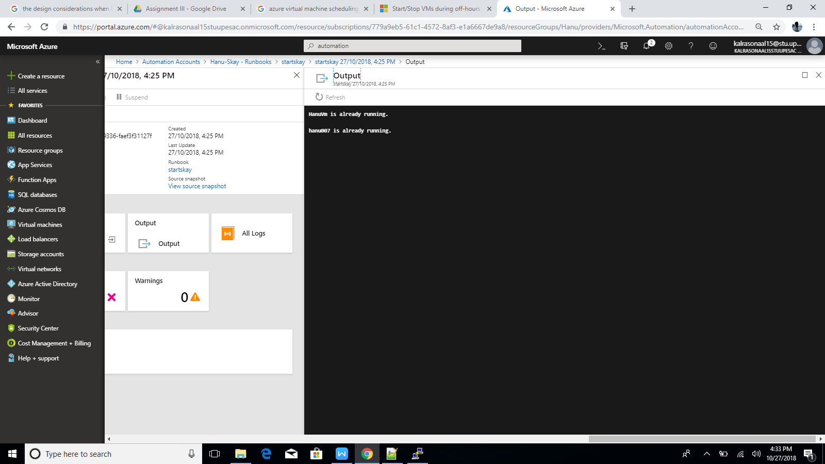

And if the VM was stopped it will get restarted again.

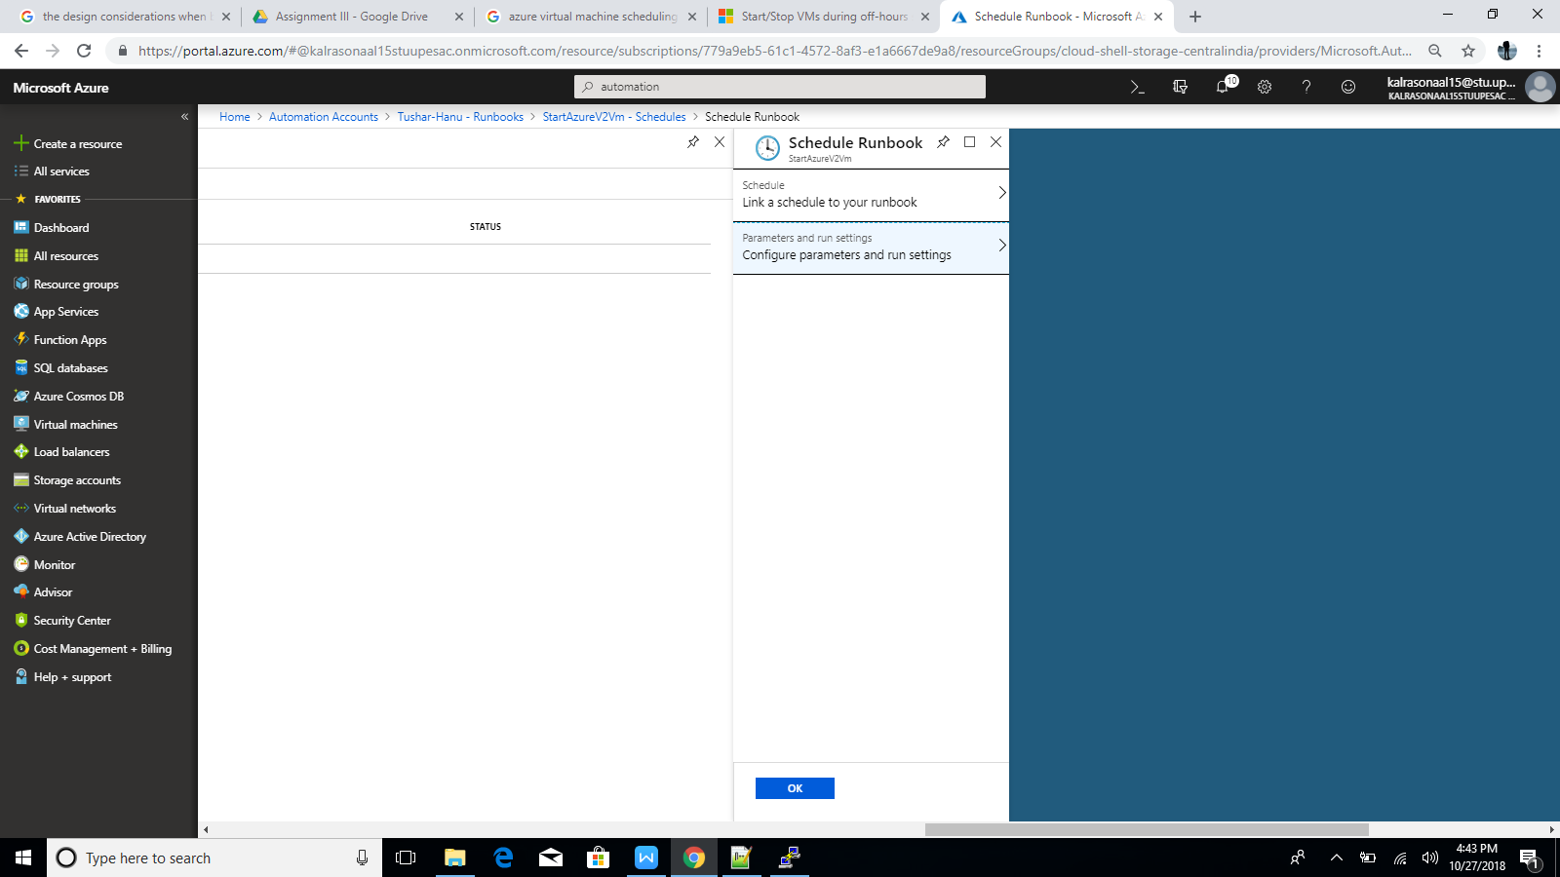

Now lets schedule by going to schedule as above:

Fill the desired details and click on create:

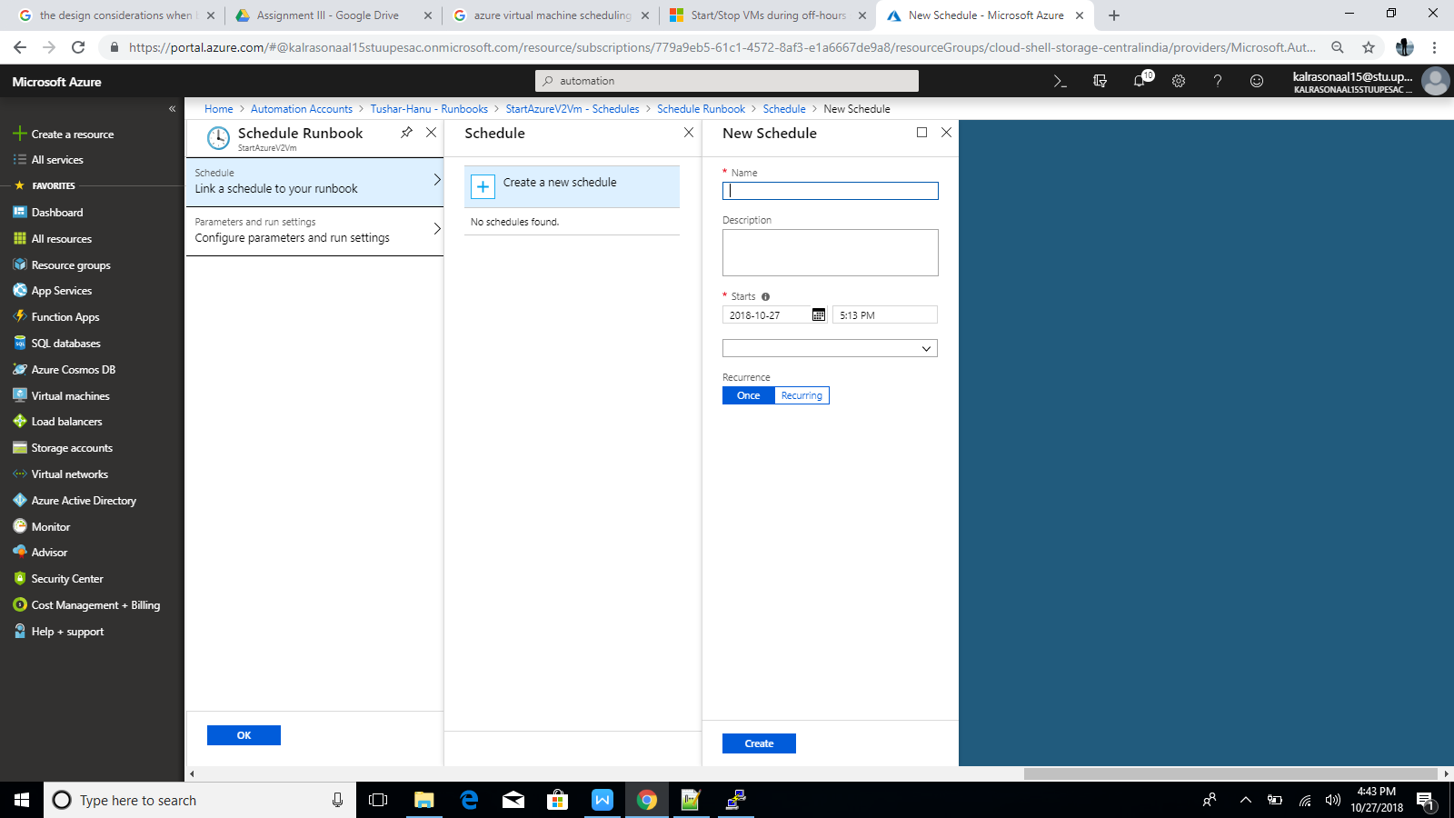

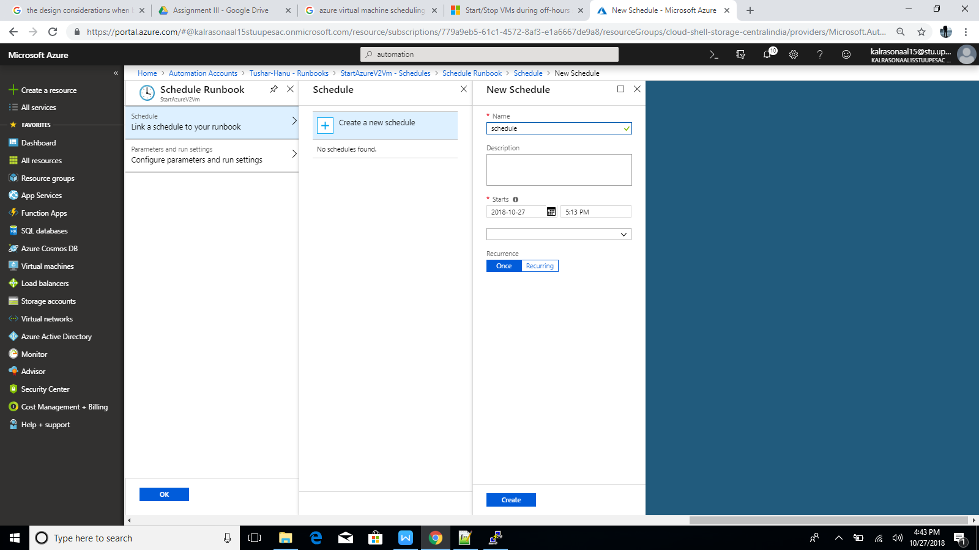

Hence the schedule has been created:

